Project overview:

The goal of this project is to make it easier for a hotel to manage their tasks such as, room booking, record keeping etc.

Technology used for this project is Front End HTML, CSS and JavaScript and for the Back End I have used JavaScript and Mysql Language

This project is divided into 3 parts

1. Front End Part for customer User
2. Front End Part for hotel admin user
3. The Back End part for server creation and database connection.

The Front End work is similar for both the Customer user and admin user so I will try to explain one of them and the concept will remain same for both

**Customer Front End:**

Let’s have a look at Airbnb folder structure

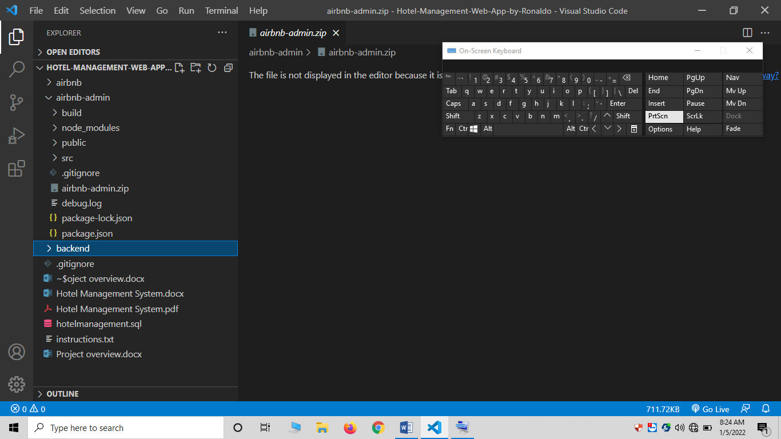

**Explaining admin section:**

Here in admin section we will discuss about the structure

We have some other folders inside the Airbnb-Admin which are build, node_modules, public and src.

* Inside the node module folder we have install all the dependencies to compile and run this project
* Inside the public folder we have an index.html, index.css file with some other file like fav icon of our web page.
* The main purpose of this index.html file is to show all the design components on the screen after rendering.
* We have another folder named as SRC, inside this src we have all our React JS components which I will explain next.
* Each element showing in the browser is a separate component for example Menu bar is a single component, login screen and registration screen are other two components
* The other Most important file is Package.JSON file where all the details of dependencies and packages are stored. We cant run this project without this file and dependencies

**Let’s discuss the components:**

As you know we have used React JS library for front end.

React JS is component base library for User Interfaces.

There are two types of components in React JS One is class based component and other is function based components

So in this project I have used Function based component for the whole UI.

Function based component are arrow functions which is advance feature of ES6.

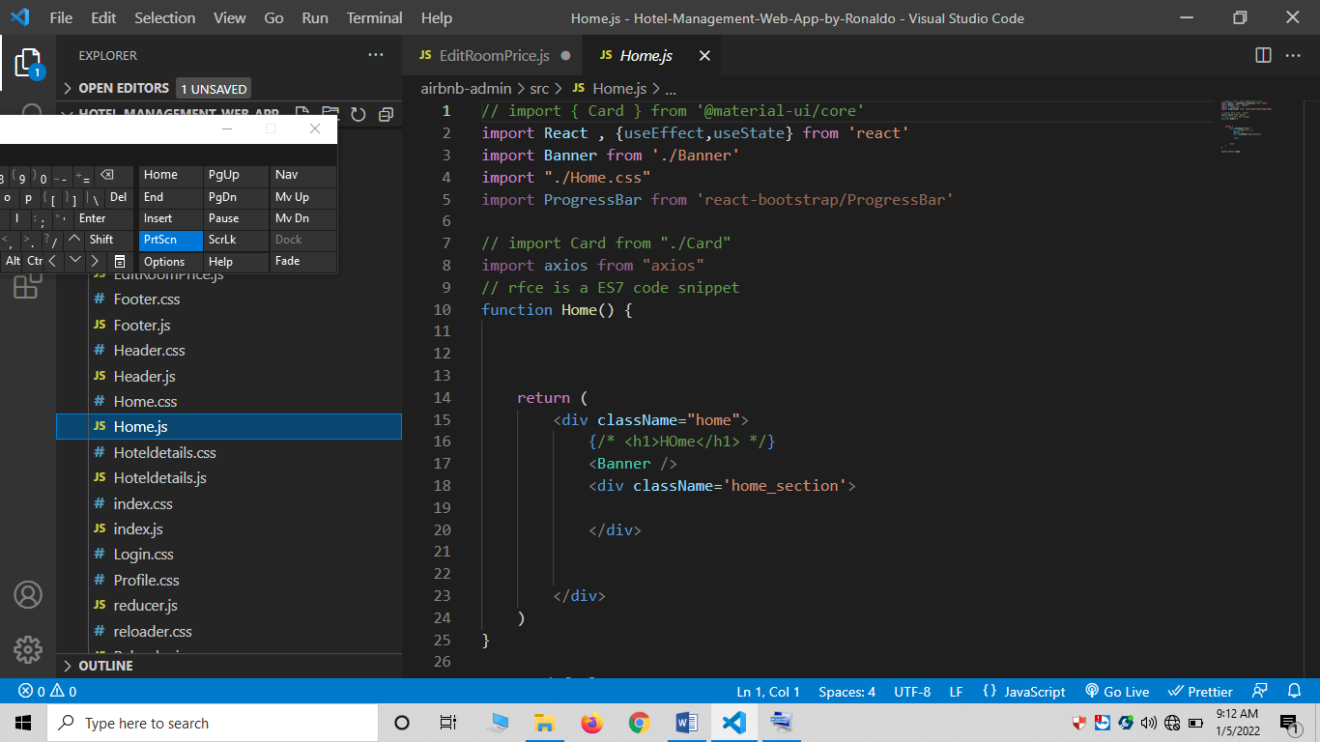For example this is a home components

In the above screenshot we have a function based component of react.

We can see we have import react and useState from the react package.

This react import allows us to use the methods of react js library.

While the import Banner from ‘./banner’ is used to import the Banner component which is in the same directory .

<Banner /> in the above screen is mean that we have imported and render the Banner inside the body of home screen

I have used CSS as a styling language, each and every component have its own css file which can be seen in the SRC folder.

For example home.js have its own home.css file for its styling.

In all my project I have used React, React-Dom, React States, React Props, Hooks and axios. Which can be seen inside the other components coding.

**Back End:**

Let’s have a look at Backend folder structure

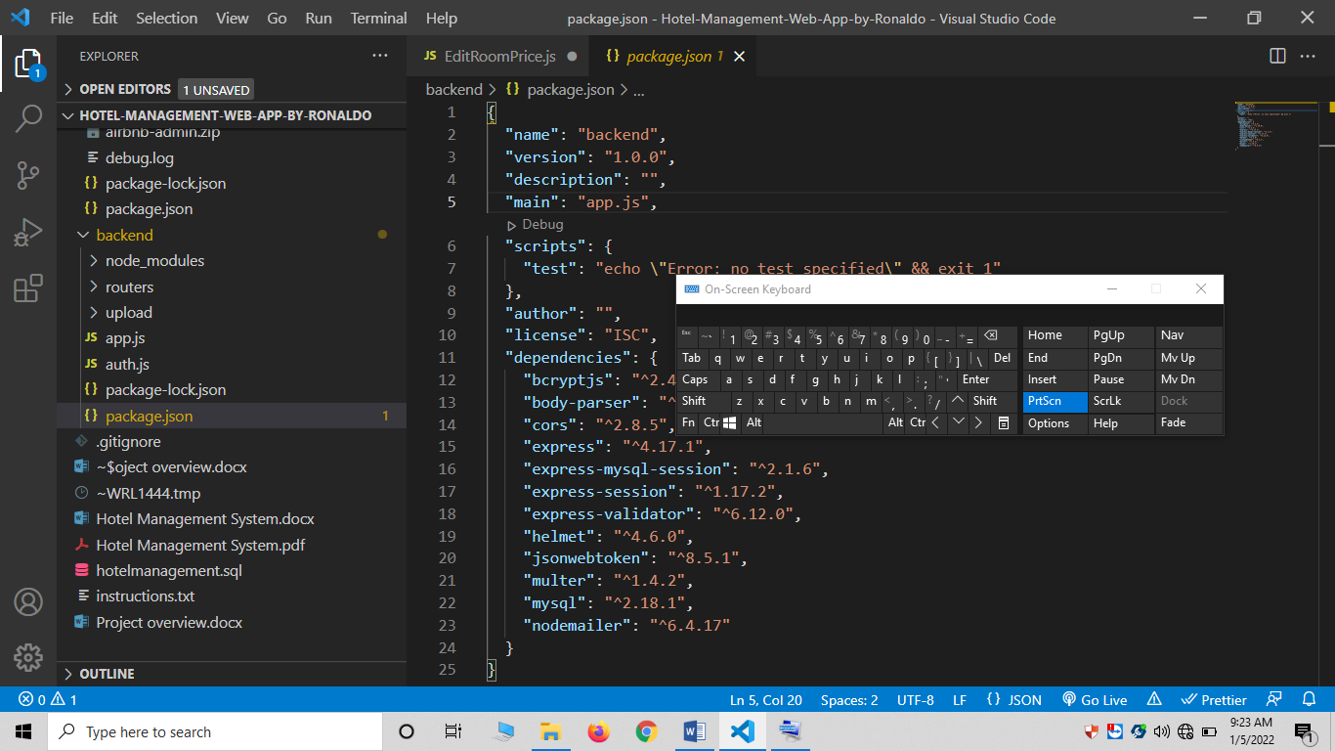

The Back end folder have all the server details and database connection file

The other most important file is package.json where all the dependencies and scripts to start server is coded.

{

  "name": "backend",

  "version": "1.0.0",

  "description": "",

  "main": "app.js",

  "scripts": {

    "test": "echo \"Error: no test specified\" && exit 1"

  },

  "author": "",

  "license": "ISC",

  "dependencies": {

    "bcryptjs": "^2.4.3",

    "body-parser": "^1.19.0",

    "cors": "^2.8.5",

    "express": "^4.17.1",

    "express-mysql-session": "^2.1.6",

    "express-session": "^1.17.2",

    "express-validator": "^6.12.0",

    "helmet": "^4.6.0",

    "jsonwebtoken": "^8.5.1",

    "multer": "^1.4.2",

    "mysql": "^2.18.1",

    "nodemailer": "^6.4.17"

  }

}

The above is the coding of package.json file.

I have use Express JS for backend server and nodjs as runtime environment.

Express js for creation of connection

Body parser for data retrieval and other are some co-dependencies.

Xammp is used to create the database for this project.

NPM is used to install the models / packages and run the server